OSI Reference Model
- OSI referred as Open System Interconnection.
- Why Invented? : When network first came into use, computer could typically communicate only with computer from the same manufactures.
- For example: Companies ran either a complete IBM solution or Linksys Solution. But not together.
- To overcome this problem ISO created OSI model.
- To help vendors create interoperable network devices and software in form of protocols so that different vendor network could work with each other.
- Describe how data and network information are communicated from an application on one computer through the network media, to an application on another computer.
- It breaks this approach into layers.
- It is the set of guideline that application developer can use to create and implement application that run on network.
- Provide framework for creating and implementing standard, devices.
Why It is Called Open System?
- Open System is a system in which its architecture is not secret and its open for anyone, who is interested in using, changing and reworking on it.
- Reference Model: Conceptual blueprint of how communication should take place.
- Layers: Reference Model Address all the process required for effective communication and divides these process into logical grouping called layers.
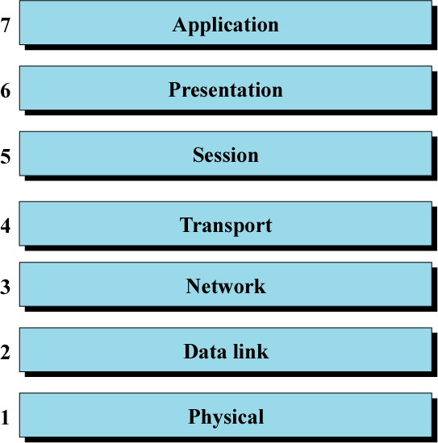
OSI Layer
- There are seven layer in OSI Model. Which are listed in diagram.
- OSI Layer divided into three groups
        - Upper Layer (Application, Presentation, Session)
        - Middle Layer (Transport)
        - Lower Layer ( Network, Data link, Physical)
UPPER LAYERS:
- Implemented in Software.
- Define how the application within the end station will communicate with each other and with user.
- Represent software that implements network services like encryption, Decryption, conversion and connection management.
- They don’t know about lower layer function.
LOWER LAYERS:
- Lower Layer define how data is transmitted end to end.
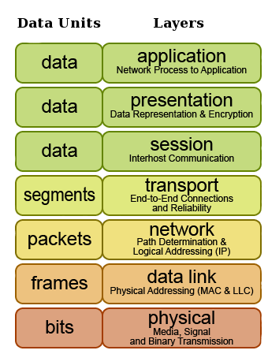
- Implement more primitive, hardware-oriented functions like routing, addressing, and flow control.
PDU
- Definition: Data exist at each layer in units called Protocol Data Unit.
- Table show the name of PDU at each layer.

ENCAPSULATION
- Encapsulation is a term used to describe adding information to PDU as they are pass down the each layer.
- When data moves from upper layer to lower level of OSI protocol stack each layer includes a bundle of relevant information called a header along with the actual data.
- The data package containing the header and the data from the upper layer then becomes the data that is repackaged at the next lower level with lower layer's header.
- Header is the supplemental data placed at the beginning of a block of data when it is transmitted. This supplemental data is used at the receiving side to extract the data from the encapsulated data packet.
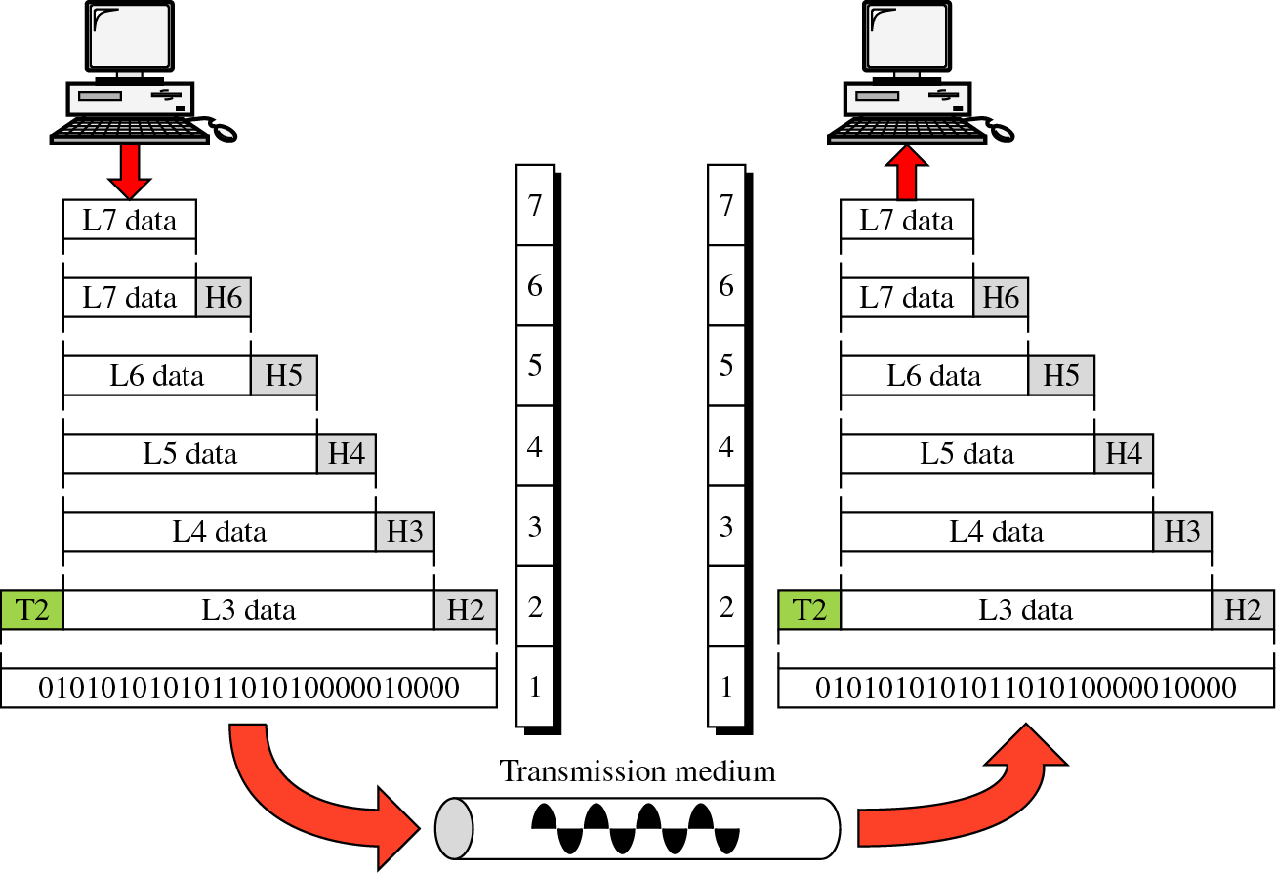
- This packing of data at each layer is known as data encapsulation.
- Other end, each layer perform dencapsulation.
- Dencapsulation means at the receiving side, each layer read and remove its header information and pass to its upper layer.
- So it is a opposite process of encapsulation.
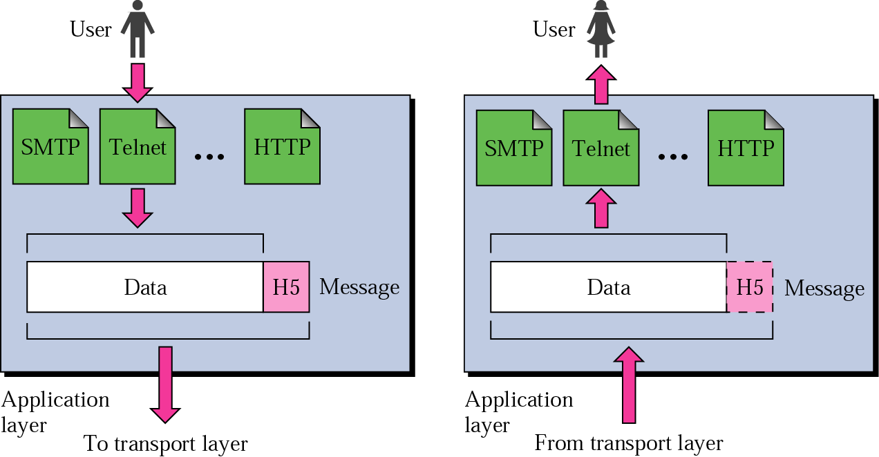
APPLICATION LAYER
- Responsible to providing services to users.
- Main interface for the user to interact with application and network services like www, telnet, email, file transfer application.
- Provide interface to user to access the information on the internet through application.
- Application layer protocols are used to exchange data between programs running on the source and destination hosts.
- Provide platform to send and receive data over the network.
Specific services provided by the application layer are the following:
- File transfer, access, and management: This application allows a user to access files in a remote host (to make changes or read data), to retrieve files from a remote computer for use in the local computer, and to manage or control files in a remote computer locally.
- Mail services: This application provides the basis for e-mail forwarding and storage.
- Directory services: This application provides distributed database sources and access for global information about various objects and services.
- Remote Login: It allows login in a host which is remote.
- World Wide Web: Accessing a web page is also a part of this layer.
Protocol :
HTTP | Hyper Text Transfer Protocol
FTP | File Transfer Protocol
SMTP | Simple Mail Transfer Protocol
TELNET | TELecommunication NETwork
POP3 | Post Office Protocol 3
DHCP | Dynamic Host Configuration Protocol
SSL | Secure Socket Layer

Data Unit OR PDU: Data

Device: Gateway.
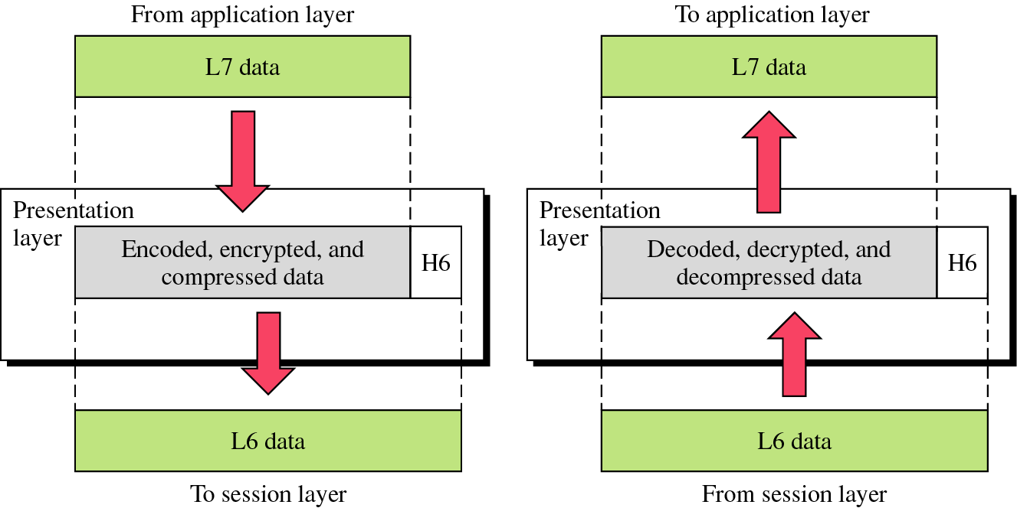
PRESENTATION LAYER
- Present data to application layer.
- Concerned with syntax and semantics of the information exchanged between two devices.
- Responsible for Translation, compression and encryption of information.

Specific responsibilities of the presentation layer are the following:
- Translation: Presentation layer at the sender changes the information from its sender dependent form to common format. The presentation layer at receiver end changes the common format to its receiver dependent format. For example: When two host are communicating with each other, they might be using different encoding standards and character set for representing data internally. For instance, one host could use ASCII code for character representation where as other use EBCDIC. The presentation layer is responsible of taking care of such differences.
- Encryption: Encryption means sender transforms the original message to another form and send resulting message out over the network.
- Compression: Reduce the number of bit contained in the information.
Protocol : S-MIME, ASCII, EBCDIC, FTP, NCP, SMTP, SMB
S-MIME | Secure Multipurpose Internet Mail Extension
ASCII | American Standard Code for Information Interchange
EBCDIC | Extended Binary Coded Decimal Interchange Code
NCP | Network Control Program.
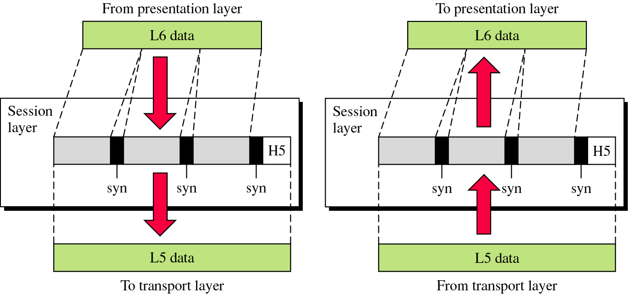
Data Unit: Data
Device used at this layer: Gateway.
SESSION LAYER
- Control communication between applications on hosts.
- Provides the mechanism for opening, closing and managing a session or connection between end-user application processes.
- It is dialog controller because it establish, maintain and synchronize the interaction among communicating devices.
- Responsible for dialog control and synchronization.
- In the connection establishment phase, the service and the rules (who transmits and when, how much data can be sent at a time etc.) for communication between the two devices are proposed.
- The participating devices must agree on the rules. Once the rules are established, the data transfer phase begins.
- Connection termination occurs when the session is complete, and communication ends gracefully.
Specific responsibilities of the session layer include the following:
- Dialog control: Allow two system to enter into dialog. Allow communication between two processes in either half or full duplex mode.
- Synchronization: Allow process to add checkpoint or synchronization point.
For example: if a system is sending a file of 2000 pages and system add checkpoint after 100 pages. So after each 100 page to ensure that each 100-page unit is received and acknowledge. During the transmission of page 523 if crash happen, the only page need to be resent after system recovery are pages 501 to 523.
Protocol :
NFS | Netware File System
SMB | Server Message Block
SQL | Structure Query Language
RPC | Remote Procedure Call
Apple Talk
Device : Gateway.
Data Unit : Data
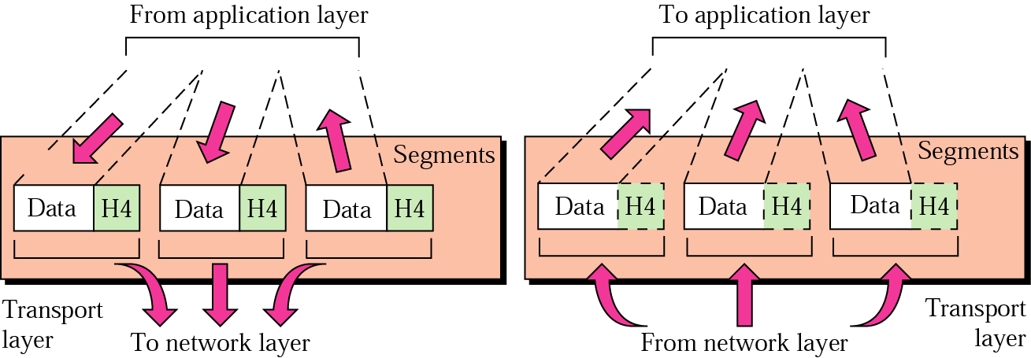
Utility Used at this layer: nbtstat
TRANSPORT LAYER
- Responsible for process to process delivery of the entire message.
- Ensure that whole message arrives intact.
- Also seeing error control and flow control at the source to destination level.
- The transport layer also determines what type of service to provide to the session layer, and, ultimately, to the users of the network.

Specific responsibilities of the transport layer include the following:
- Two types of service provided by transport layer: Reliable and Unreliable.
Reliable service is one that make sure that data is not lost during transmission and to provide data error free. It ensure that the receiver acknowledge the receipt of each packet .
Unreliable Service doesn’t make mechanism to ensure that the receiver did receive the data sent.
- Connection control: Transport layer can be either connection less or connection oriented.
Connection Oriented :
- First establish logical connection with receiver.
- Send all packet through the connection.
- Receiver send acknowledge after receiver packet.
- Terminate connection.
- Receiver receive packet in sequence.
- TCP is a connection oriented protocol.
Connection Less :
      - The sender doesn’t establish a contact with receiver.
      - Each packet route to different path.
      - Receiver doesn’t send acknowledgement.
      - UDP is a connection less protocol.
      - Segmentation and Reassembly : A message is divided into transmitted segments, with sequence number. These number enable to the transport layer at other end to identify and reassemble packet.
- Service Point Addressing ( Port Address): To deliver message from one computer’s specific process to other computer’s specific process Transport layer add Port address or service point address.
- Error Control: Error control performed process to process. Sending transport layer make sure that entire message arrive at the receiving transport layer without error. Error control achieve through retransmission.
- Flow control. :Like the data link layer, the transport layer is responsible for flow control. However, flow control at this layer is performed end to end rather than across a single link.
- Protocol :
TCP | Transmission Control Protocol
UDP | User Datagram Protocol
SCTP | Stream control Transmission Protocol
SPX | Sequence Packet Exchange

- Device : Gateway
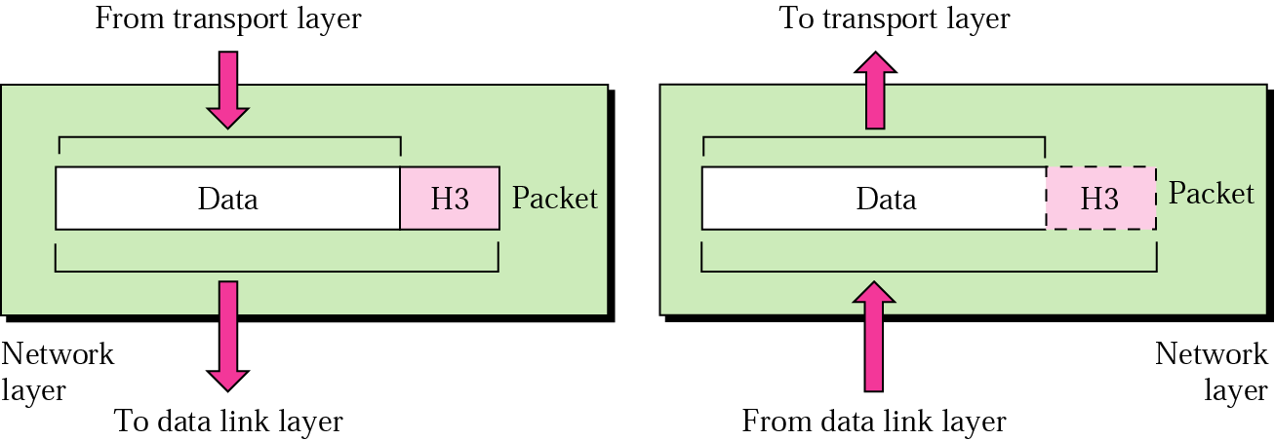
NETWORK LAYER
- Responsible for the delivery of individual packets from the source host to destination host.
- Deliver packet across multiple network.
- If two system are connected to the same link, there is no need for network layer.
- It two system are attached to different network with connecting device, there is need for network layer.
Other responsibilities of the network layer include the following:
- Logical addressing: The physical addressing implemented by the data link layer handles the addressing problem locally.
If a packet passes the network boundary, we need another addressing system to help distinguish the source and destination systems.
The network layer adds a header to the packet coming from the upper layer that, among other things, includes the logical addresses of the sender and receiver.
- Routing: When independent networks or links are connected to create intemetworks(network of networks) or a large network, the connecting devices(called routersor switches) route or switch the packets to their final destination.
- Protocol :
Protocol | Full Name
IP | Internet Protocol
RARP | Reverser Address Resolution Protocol
OSPF | Open Shortest Path First
ICMP | Internet Control Message Protocol
IPX | Internetwork Packet eXchange
IGRP | Interior Gateway Routing Protocol
EIGRP | Enhanced Interior Gateway Routing Protocol
BGP | Border Gateway Protocol

- Device : Router
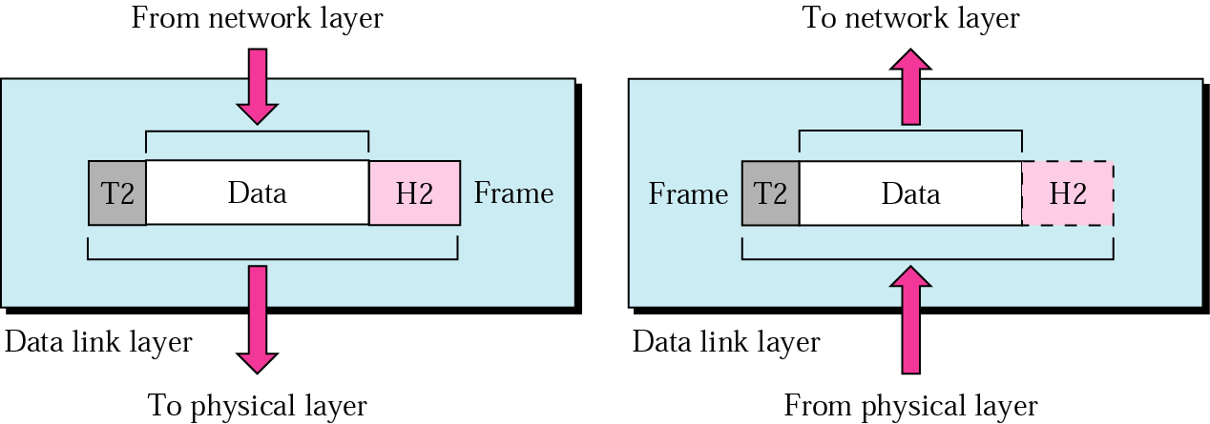
DATA LINK LAYER
- Responsible for moving group of data or frame over a common local media.
- Transform physical layer bit stream to reliable link.
- Makes Physical layer error free to upper layer.
- It add header and trailer information to frame.
- The header contain the physical address and other control information.
- This address change as the frame travels from different nodes on a route from the source node to destination node.
- Data link layer has two sub layer
LLC (Logical Link Control) :
      - Upper most part of Data link layer
      - Responsible for error checking, flow control and synchronization.
MAC (Media Access Control)
- Responsible for addressing in LAN, determine when nodes on LAN are allowed to transmit.
Other responsibilities of the data link layer include the following:
- Framing.
The data link layer divides the stream of bits received from the networklayer into manageable data units called frames.
- Physical addressing.
If frames are to be distributed to different systems on thenetwork, the data link layer adds a header to the frame to define the sender and/orreceiver of the frame.
If the frame is intended for a system outside the sender'snetwork, the receiver address is the address of the device that connects the networkto the next one.
- Flow control.
If the rate at which the data are absorbed by the receiver is less thanthe rate at which data are produced in the sender, the data link layer imposes a flowcontrol mechanism to avoid overwhelming the receiver.
- Error control.
The data link layer adds reliability to the physical layer by addingmechanisms to detect and retransmit damaged or lost frames.
It also uses a mechanism to recognize duplicate frames. Error control is normally achieved through atrailer added to the end of the frame.
- Access control.
When two or more devices are connected to the same link, datalink layer protocols are necessary to determine which device has control over thelink at any given time
- Protocol : Ethernet, HDLC, SDLC, FDDI, MPLS ( Multi Protocol Label Switching)
- Device : Hub, Switch, Bridge
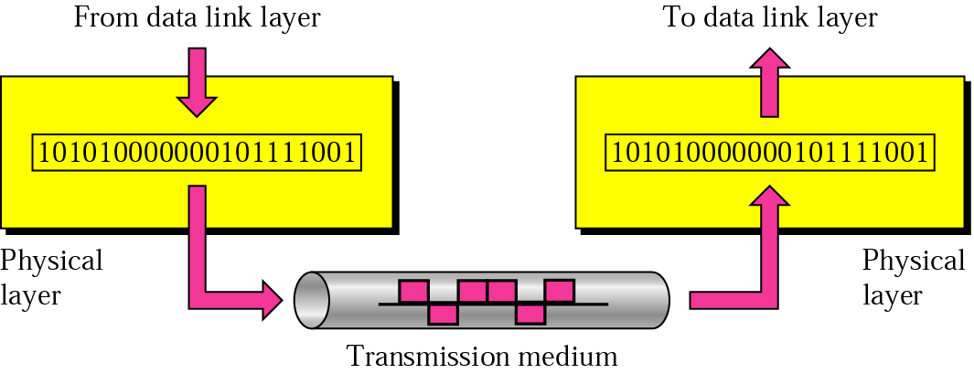
PHYSICAL LAYER
- To carry bit stream over a physical medium.
- Deal with electrical specification of transmission medium.
- Define procedure and function that physical device has to be perform for transmission.

The physical layer is also concerned with the following:
- Physical characteristics of interfaces and medium: The physical layer defines the characteristics of the interface between the devices and the transmission medium. It also defines the type of transmission medium.
- Representation of bits: The physical layer data consists of a stream of bits(sequence of Os or 1s) with no interpretation. To be transmitted, bits must beencoded into signals--electrical or optical. The physical layer defines the type ofencoding (how Os and I s are changed to signals).
- Data rate: The transmission rate-the number of bits sent each second-is alsodefined by the physical layer. In other words, the physical layer defines the duration of a bit, which is how long it lasts.
- Synchronization of bits: The sender and receiver not only must use the same bitrate but also must be synchronized at the bit level. In other words, the sender and the receiver clocks must be synchronized.
- Line configuration: The physical layer is concerned with the connection of devices to the media. In a point-to-point configuration, two devices are connected through a dedicated link. In a multipoint configuration, a link is shared among several devices.
- Physical topology: The physical topology defines how devices are connected to make a network. Devices can be connected by using a mesh, star, and ring or bus topology.
- Transmission mode: The physical layer also defines the direction of transmission between two devices: simplex, half-duplex, or full-duplex.

DIFFERENCE : OSI MODEL Vs TCP/IP MODEL
OSI | TCP/IP
OSI is reference model | Implementation of OSI model.
7 layer architecture | Only 4 layer architecture.
Generic protocol independent standard. | Standard around which internet has developed.
Concept of service, interface and protocol are well explained. | Not clear explanation of services, protocol and interface.
Provide connection oriented service at transport layer. | Provide connection less and connection oriented service.
Provide only connection less and connection oriented service at network layer | Provide only connection less service at network layer.
All layer are separate. | Combine presentation and session layer into application layer and data link and physical layer into network access layer.

SUMMARY OF LAYERS:
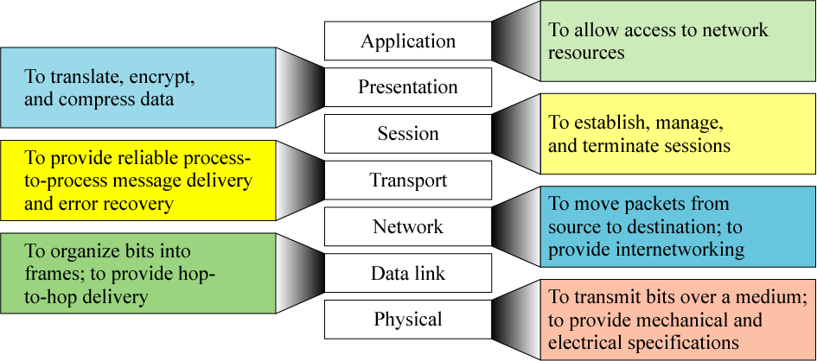
Long Questions
1 | Explain responsibility of application and transport layer. |  | MA2015 | 5
2 | Explain devices used at Physical layer. |  | MA2013 | 8
3 | Discuss in detail about layers of OSI Model |  | ON2012 | 8
4 | Explain about data link layer in detail |  | ON2011,MA2010 | 5
5 | Discuss OSI Reference model in detail |  | ON2011,09,MA2011,10,09,ON2008 | 8
Short Questions
1 | List Protocol used in network and transport layer. | MA2012
2 | Explain connection oriented and connection less services. | ON2011
3 | Which protocols are applicable at application layer and data link layer? | MA2011,08,10,ON2009
4 | What is Packet? | MA2009
5 | Give name of two protocol which work at network layer. | ON2008
6 | Which layer are responsible for routing packets? | MA2008

EXPLAIN HOW TO CONFIGURE TCP/IP
OR WRITE A STEP FOR BASIC AND ADVANCE CONFIGURATION OF TCP/IP
OR WRITE A STEP TO INSTALL AND CONFIGURE TCP/IP
To install and configure the TCP/IP network protocol on Windows 2000, Windows XP, and Windows Server 2003:
- Click Start –>Settings –>Control Panel.
- On the control panel, double-click Network and Dial-Up Connections.
- Right-click Local Area Connection.
- Click Properties.
If Internet Protocol (TCP/IP) does not appear in the list, do the following:
  - Click Install.
  - Select Protocol, and then click Add.
  - Select Internet Protocol (TCP/IP).
  - Click OK. This returns you to the Local Area Connection Properties window.
- Select Internet Protocol (TCP/IP), and then click on Properties.
- Select Using the Following IP Address.
- Click the IP Address tab.
- Click Specify an IP address.
- Enter the IP address of your PC (for example, 199.5.83.205).
- Enter the Subnet Mask (for example, 255.255.255.0).
- If you are using a default route, click Gateway, and do the following:
- Enter the IP address of the gateway or router in New gateway.
- Click Add.
f. If you are using a domain name server, click DNS, and do the following:
- Enter the host name of your PC (for example, cameron).
- Enter the domain (for example, acme.com).
- Enter the IP address of the domain name server.
- Click OK.
- Click OK on the Local Area Connection Properties window. It is not necessary to restart your PC.
IP ADDRESS
- A Unique 32-bit address.
- Used by computers to communicate over a computer network.
- Known as :Logical Address.
- It is a software address assigned to each machine on network.
- Why Need? : Necessary for Universal communication services that are independent of underlying networks.
- Used In : Universal Addressing System
- Universal Addressing System is one where each host can be identified uniquely regardless of the underlying physical network.
- Used at Network layer of OSI Model.
- Designed to allow a host on one network to communicate with host on a different network.
- We can change IP Address but can’t change MAC Address because it is hard coded on NIC.
- Each IP address has two fundamental parts:
    - Network Address.
    - Host Address.
Network Number or Address:
- Uniquely identify each network.
- This number is common to all computers on the same network and define the network group the computer belong to.
Host Number:
- Consist number that are unique to each computer on the network.
- Useful to uniquely identify each computer on the network.

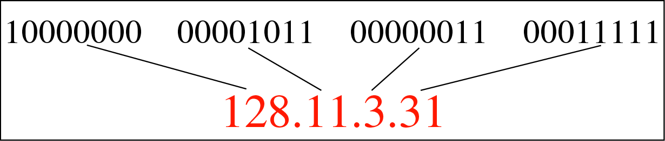
128.11 : Network Addressand3.31 : Host Address

- IP addresses are written in dottedDecimal format and Binary format.

- We cannot mix binary notation and decimal notation to write down IP Address.

Dotted Decimal Format:

Dots separate the sections
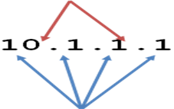
Each section contains a number between 0 and 255

- Four sections are separated by dots.
- Each section contains a number between 0 and 255.
- Each section is known as OCTET.

Binary Format:
- To write ip address into binary format we use “1” and “0”.
- Each octelcontail 8 bits. Because 32 bit / 4 boctet = 8 bit / octel.

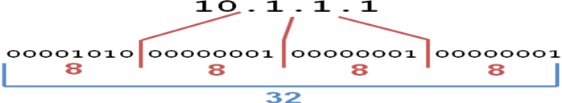
Each 8 digit group represents a number between 0 and 255

Why is each section a number between 0 and 255?
- Computers operate in binary, humans operate in decimal.
- Computers treat IP addresses as a single large 32 digit binary number, but this is hard for people to do.
- So, we split them up into four smaller sections so we can remember and work with them better
It is structure or hierarchical Address.
- IP address is used in routing.
- If every machine has unique address then all router on the internet would need to store the address of each and every machine on the internet.
- This make router inefficient.
- Solution :32 bit is divided into two parts.
  - Network Address
  - Host Address

ADDRESS SPACE
- Definition:A protocol such as IPv4 that defines range of addresses which is also called as address space.
- An address space is the total number of addresses used by the protocol.
- The address space in a protocol That uses N-bits to define an address is: 2^{N}.
- IPv4 uses 32-bit addresses, which means that the address space is 2³²or 4,294,967,296 (more than 4 billion).
- This means that, theoretically, more than 4 billion devices as mentioned above could be connected to the Internet.

DIFFERENCE :MAC ADDRESS Vs IP ADDRESS
MAC address | IP address
Functions at data link layer | Functions at network layer
It is a physical address | It is a logical address
It is fixed. | It changes with the relocation of device from one network to another
It is a 48 bit address | It is a 32 bit address

CLASSFUL ADDRESSING
- IPv4 addressing used the concept of classes.This architecture is called classfull addressing.
- In classfull addressing, the address space is divided into five classes: A, B, C, D, and E.
- Each class occupies some part of the address space.
- If the address is given in binary notation, the first few bits can immediately tell us the class of the address.
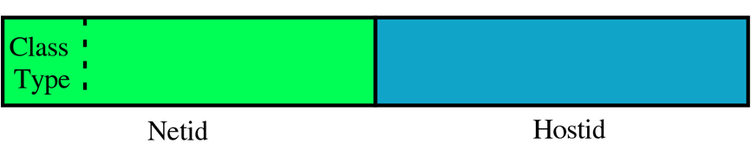
Why Devided into Classes?:IP addresses are divided into classes so that they can be assigned to a particular business, government or other entity based on size and need. There are five IP classes plus certain special addresses
- If the address is given in decimal-dotted notation, the first byte defines the class.
- when IP was developed, the IP address space was divided into distinct IP address classes to determine where the network portion stops and the host portion begins.
- The value of the first octet and its highest order (leftmost) bits determine the class.
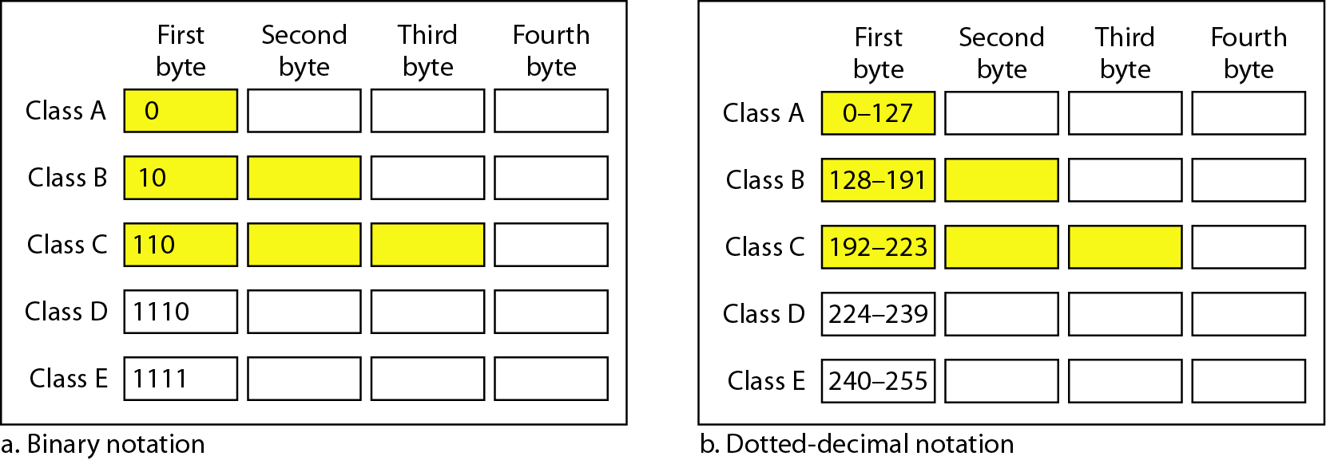
- There are five IP address classes, three of which (A, B, and C) are available for commercial use. Class D is reserved for IP multicasting. Multicasting allows multiple computers in the same multicast group to receive the same data transmission, sort of like a directed broadcast.
- Class E is strictly reserved for research use by the Internet Engineering Task Force

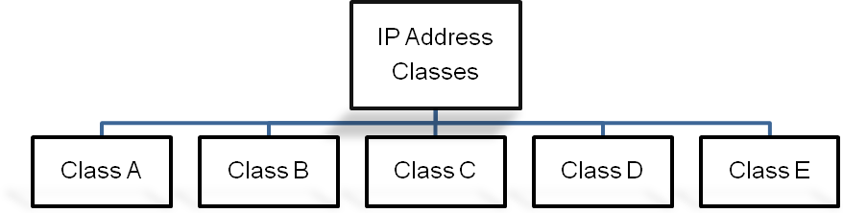

CLASS A
- In a Class A IP address, the network portion is represented by the first octet; it has in its leftmost bit.
- All Class A IP addresses fall into the 0-127 range for the first octet.
- This also results in 127 possible networks and a maximum of 16,777,214 hosts on each network. (Please note that the network 127.0.0.0 is reserved for loopback addresses.) Figure summarizes the characteristics of the Class A address class.

CLASS B
- In a Class B IP address, the first and second octets represent the network portion; it has 10 in its two leftmost bits.
- A Class B IP address falls into the 128 to 191 range for the first octet.
- This results in 16,384 possible networks and a maximum of 65,534 hosts on each network.
CLASS C
- In a Class C IP address, the network portion is represented by the first, second, and third octets; it has 110 in its three leftmost bits.
- A Class C IP address falls into the 192 to 223 range for the first octet. This results in 2,097,152 possible networks and a maximum of 255 hosts on each network.
SUBNET MASK
- Subnet mask is used to differentiate Network ID and Host ID.
- Each class has Default Subnet Mask in classful Addressing.
- To differentiate ,perform ANDoperationwith IP Address and Subnet Mask.
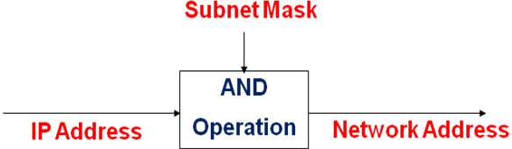
Definition:32 bit value that allow recipient of IP packets to distinguish the network id and host id portion of the IP Address.”
DEFAULT SUBNET MASK
- Class A, B and C contains 1s in network ID fields for default subnet mask.
- The bits of the subnet mask are defined as follows:
  - All bits that correspond to the network ID are set to 1.
  - All bits that correspond to the host ID are set to 0.
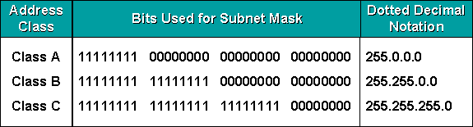
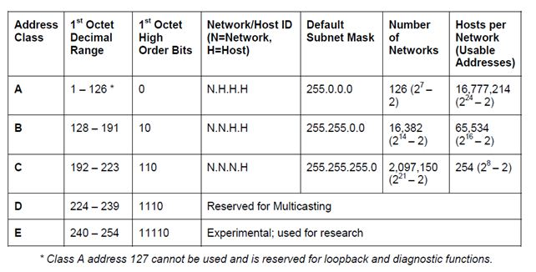
Note that we must not apply the default mask of one class to an address belonging to another class.

HOW TO FIND NETWORK ID IN CLASSFUL ADDRESS?
SHORTCUT METHOD:
- If the byte in the mask is 255, copy the byte in the address.
- If the byte in the mask is 0, replace the byte in address with 0.
For example:
Given the address 23.56.7.91, find the beginning address (network address).
IP | 23 | 56 | 7 | 91
SUBNET MASK | 255 | 0 | 0 | 0

NETWORK ID | 23 | 0 | 0 | 0

OR From the first octet value we get idea about the class. Here 23, it is reside between “0-128” so its class A address. In Class A , only fist octet define network id and other octet define host address so we cant need to do above trick or apply Anding operation .
DEFAULT GATEWAY
- It is a term used by TCP/IP for a Router.
- IP address of a router on the same subnet is called the default Gateway.
- Subnet Mask is to identify whether the source and destination machines are on the same subnet.
- In the destination machine is on the another subnet then the message is sent through routers.
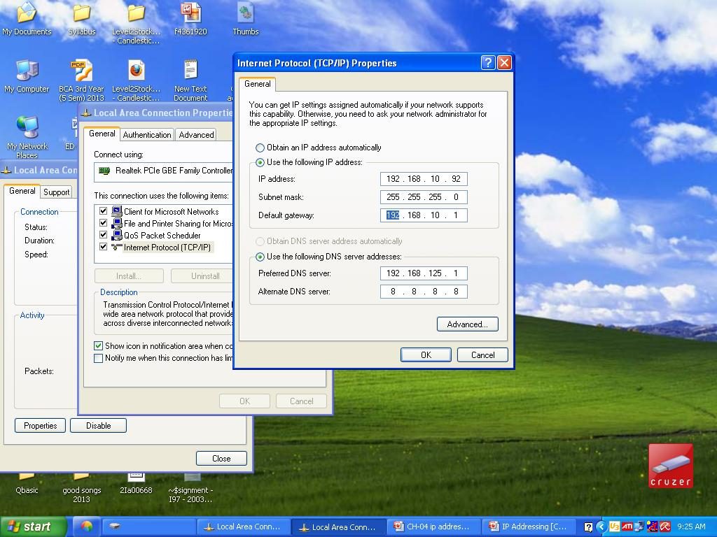
PING UTILITY:
- Full Form : Packet InterNetGroper Utility
- Diagnostic Tool used for troubleshooting purpose.
- Use from command prompt by writing : ping <computer ip address/host name>
To check connection between two machines.
- Use:
    - To test TCP/IP configuration and to identify connection failures.
    - To determine whether a destination is alive and reachable.
IPCONFIG
- Full Form : InternetPacket Configuration
- Displays all current TCP/IP network configuration values
- Refreshes Dynamic Host Configuration Protocol (DHCP) and Domain Name System (DNS) settings.
- Used with /all(ipconfig /all)parameters, ipconfig displays the IP address, subnet mask, and default gateway for all adapters with host name.
PRIVATE ADDRESSES:
- Used by anyone on Private Network.
- Are not routable .
- Can not access from internet.
- Save IP Address Space.
- Internet Assigned Numbers Authority (IANA) has reserved certain IP addresses as private addresses for use with internal web sites or intranets.
- These are also referred to as RFC 1918 addresses.
- If every host on network as real routable IPaddress , we would have run out of IP Address space.
- Used forcomputer not directly connected with internet.
- Used by company for internal network
CLASS | RESERVED ADDRESS SPACE | AVAILABLE ADDRESS
A | 10.0.0.0 - 10.255.255.255 | 16,777,216
B | 172.16.0.0 - 172.31.255.255 | 1,048,576
C | 192.168.0.0 - 192.168.255.255 | 65,536
PUBLIC ADDRESSES:
- A public IP address is any valid address, or number, that can be accessed over the Internet.
- Internet standards groups, such as the Internet Assigned Numbers Authority (IANA), are the organizations responsible for registering IP ranges and assigning them to organizations, such as Internet Service Providers (ISPs).

LOOPBACK ADDRESSE:
- 127.0.0.1 is a Loopback Address
- Use:
    - A host can use this to send message back to itself.
    - Primarily for Troubleshooting and network testing.
- It check if the TCP/IP protocol stack on machine is working properly or not.
- 127.0.0.0 to 127.255.255.255 reserve for loopback address

TYPES OF IP ADDRESS CONFIGURATION
There are two types
- Static
- Dynamic
Static
- Manually input by network administrator.
- Manageable for small networks.
- Requires careful checks to avoid duplication.
Dynamic
- Assigned by server (DHCP ) when host boots.
- Derived automatically from a range of addresses.
- Duration of ‘lease’ negotiated, then address released back to server.
IP SUBNETTING
Why we need?
- IP address classes are not always the most efficient way to design an IP addressing scheme. There aren't many companies that need a Class A address with 16 million hosts, and there may be smaller companies that need more addresses than a Class C network can provide. As you can see, this method could lead to a tremendous number of wasted IP addresses
- The Internet Engineering Task Force (IETF) saw this and submitted RFC 950 to facilitate the addition of a third level to the existing two-level hierarchy created with IP address classes. This third level is known as subnetting.
- Definition :Subnettingallows you to divide a network into smaller sub-networks.
- Use parts of the host IDs for subnetting purpose.
- Subnets are created by taking leftmost bits from the host portion of an IP address and applying them to the network portion (see Figure).
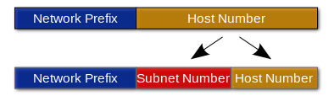
- Each subnet has its own sub-network address.
- Subnet can be created within Class A, B, or C based networks.
- In class C address, 8 bit used for Host address,so if we want to subnet, we have to use some bit from host address.

METHOD TO FIND NUMBER OF SUBNET AND HOST ADDRESS PER SUBNET

Number of Subnet: 2^{X}Where x is the number of masked bits , or the ‘1’s.
To find the number of subnet, we have to count number of ‘1’ in subnet mask.
2^{N}-2.
For example: In class A subnet mask is 255.192.0.0 (11111111.11000000.00000000.00000000). Total on bit means 1 in subnet mask is 8. So we get 2² = 4sub network address.

Number of Host Address Per Subnet: 2^{y}-2, Where y is the number of unmasked bits or the ‘0’s.
To find the number of host address per subnet, we have to count number of ‘0’ in subnet mask.
For exampleIn class A subnet mask is 255.192.0.0 (11111111.11000000.00000000.00000000). Total off bit means ‘0’ in subnet mask is 22. So we get 2²²-2network address.

Valid Subnet: 256 – subnet mask = block size or increment number.
For example: In class A subnet mask is 255.192.0.0 (11111111.11000000.00000000.00000000).
Here we get : 256 – 192 = 64. So the block size of 192 mask is always 64.
Start counting at zero in blocks of 64 until we reach the subnet mask and there are our subnets.
Here we get following subnet :0, 64, 128, 192

Broadcast Address of Each Subnet:Broadcast address is always the right number before the next subnet.
For example: The ‘0’ subnet has a broadcast address of 63 because the next subnet is 64. The 64 subnet has a broadcast address of 127 because the next subnet address is 128. Note that the broadcast address of last subnet is always 255. So , in above example the broadcast address of subnet ‘192’ is 255.

SUBNETTING PRACTISE EXAMPLES
Find the number of subnet, number of host per subnet, valid subnet and broadcast address for following Class “C” network address.
Network Address | 192.168.10.0
Subnet Mask | 255.255.255.192

Here we get network address of Class ‘C’ address because from the first octet ‘192’ we say that its class ‘c’ address.
Now , we convert subnet mask and default mask of class “C” address in binary format
Default Subnet mask | 255.255.255.0 | 1111 1111. 1111 1111. 1111 1111. 0000 0000
Subnet Mask | 255.255.255.192 | 1111 1111. 1111 1111. 1111 1111. 1100 0000

Here we on 2 bit from host address part of class “C” address.
To give all answer of above question we concentrate on Host octet. In class “C” address last octet means only last 8 bit are used for host address.
Number of Subnet: 2^{x} = 2²since 192 ( 1100 0000)where 2 is ON bit from default mask.
Number of Host Per Subnet: From above table we see that 6 bits of last octet are off. So from the method 2^{y} – 2, we get 2⁶ – 2 = 62 host.
Valid subnet: 256 -192 = 64
To find valid subnet , we start from the 0 so valid subnets are: 0,64,128,192.
Broadcast Address of Each Subnet: The number right before the next subnet is broadcast address of subnet.
Check the table for Fist host address, Last host address and broadcast address of each subnet.

Subnet | 0 | 64 | 128 | 192
First Host Address | 1 | 65 | 129 | 193
Last Host Address | 62 | 126 | 190 | 254
Broadcast Address | 63 | 127 | 191 | 255

From the use of above table find the subnet of following IP address
Node Address | 192.168.10.88
Subnet Mask | 255.255.255.192

- Now check the above table , we say that from IP Address : 192.168.10.88 its class c address so that first 3 octet display Netid and last octet display Node or Host ID. Here 88 is Host id.
- Now from the table , we say that “88” is come between subnet number 64 and 128.
- So the network id for IP Address : 192.168.10.88 is 192.168.10.64
OR
SHORT CUT METHOD
- If the byte in the mask is 255, copy the byte in the address.
- If the byte in the mask is 0, replace the byte in the address with 0.
- If the byte in the mask is neither 255 nor 0, we write the mask and the address in binary and apply the AND operation
Node Address | 192.168.10.88
Subnet Mask | 255.255.255.192

Subnet Address | 192.168.10.64
- Here we copy all octet above the 255, so we copy 192.168.10.
- But for last octet in subnet mask is not 255, so we take both number from Node address and Subnet Mask and change it in binary form and perform AND operation.
88 | 0101 1000
192 | 1100 0000
AND | 0100 0000
- Here the final result is : 0100 0000 = 64. So we get last octet.
- Now write Full subnet address : 192.168.10.64
Exercise:A company is granted the site address 201.70.64.0 (class C). The company needs six subnets. Design the subnets, Find number of host per subnet andFind the broadcast address.
- The company needs six subnets.
- This number 6 is not a power of 2.
- The next number that is a power of 2 is 8 (2³).
- We need 3 more 1s in the subnet mask. The total number of 1s in the subnet mask is 27 (24 + 3).
- The total number of 0s is 5 (32 - 27). The mask is 255.255.255.224
1111 1111. 1111 1111 .1111 1111 .11100000
- Here we on 3 bit from host address part of class “C” address.
- To give all answer of above question we concentrate on Host octet. In class “C” address last octet means only last 8 bit are used for host address.
- Number of Subnet: 2^{x} = 2³since224( 1110 0000)where 3 is ON bit from default mask.
- Number of Host Per Subnet: From above table we see that 6 bits of last octet are off. So from the method 2^{y} – 2, we get 2⁵ – 2 = 30 host.
- Valid subnet: 256 - 224 = 32
- To find valid subnet , we start from the 0 so valid subnets are: 0,32,64,96,128,160,192,224.
- Broadcast Address of Each Subnet: The number right before the next subnet is broadcast address of subnet.
- Check the table for Fist host address, Last host address and broadcast address of each subnet.
Subnet | 0 | 32 | 64 | 96 | 128 | 160 | 192 | 224
First Host Address | 1 | 33 | 65 | 97 | 129 | 161 | 193 | 225
Last Host Address | 30 | 62 | 94 | 126 | 158 | 190 | 222 | 254
Broadcast Address | 31 | 63 | 95 | 127 | 159 | 191 | 223 | 255
Exercise:A company is granted the site address 181.56.0.0 (class B). The company needs 1000 subnets. Design the subnets.
- The number of 1s in the default mask is 16 (class B).
- The company needs 1000 subnets.
- This number is not a power of 2.
- The next number that is a power of 2 is 1024 (2¹⁰). We need 10 more 1s in the subnet mask.
- The total number of 1s in the subnet mask is 26 (16 default mask + 10 from host address).
- The total number of 0s is 6 (32 - 26).
- The mask is : 255.255.255.192
11111111 .11111111 .1111 1111. 11000000
- The number of subnets is 1024. Because we have 10 bit on.
- The number of addresses in each subnet is 2⁵(5 is the number of 0s) or 32.

PROTOCOL
- Set of predefined rules used by devices in network for data transfer.
- Each layers of OSI Model and TCP/IP uses different protocols to provide services to upper layer and lower layer.
- Following figures shows the TCP/IP Protocol suite.
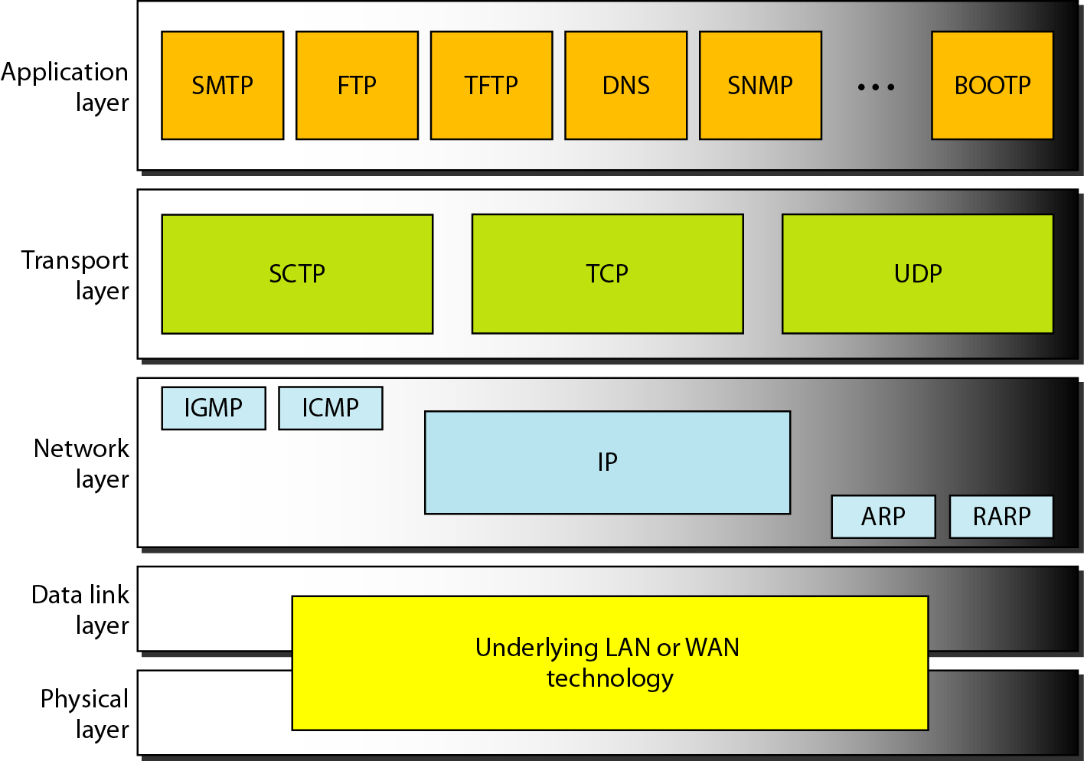
NETWORK LAYER PROTOCOLS:
- Network layer protocols is used to delivery of packet node to node.
- Network layer support internetworking protocols.
- IP is a main protocol at Network layer which is uses the services of other supporting protocol : ARP, RARP, ICMP, IGMP.
IP ( INTERNET PROTOCOL )
- The Internetworking Protocol (IP) is the transmission mechanism used by the TCPprotocols.
- It is an unreliable and connectionless protocol-a best-effort delivery service.
- The term best effort means that IP provides no error checking or tracking.
- IP assumestheunreliability of the underlying layers and does its best to get a transmission throughto its destination, but with no guarantees.
- IP transports data in packets called datagrams, each of which is transported separately.
- It is unreliable and connectionless protocol.
- Each datagram is handled independently.
- Datagram can travel along different route.
- Arrive out of sequence or duplicated.
- Does not keep track of the routes and has no facility for reordering datagram at destination machine.
- To overcome of all above problem, IP relies on higher level protocol.
- if reliability is important, IP must be paired with reliable protocol such as TCP.

IP HEADER
- A datagram is variable length packet consists of two part:
      - Header
      - Data
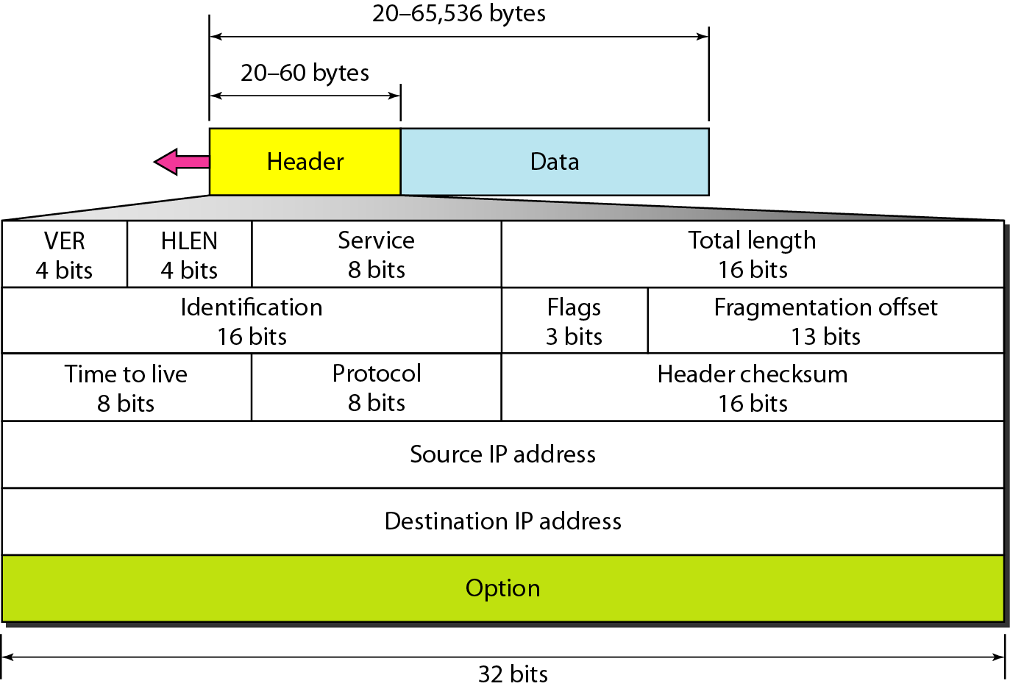

Header
- 20 to 60 bytes in length.
- Contain information essential to routing and delivery.
Version (VER)
    - 4 bit field
    - Define the version of IP Protocol.
    - There are two verson : ver. 4 and ver.6
    - This field tells the destination machine that the datagram has the format of version 4.
    - Interpreted all field as specified version in VER field.
Header Length (HLEN)
    - 4 bit field
    - Define the total length of the header in 4 bytes word.
    - Important because header length is variable( 20 to 60 B).
    - When there is no option, header length is 20 bytes and value of this field is 5 bytes ( 5 * 4 = 20 ).
    - When there is option field, its values is 15 (15 * 4 =60B).
Differentiated Services (DS)
    - 8 bit field.
    - First 6 bit make up the codepoint and last 2 bit isn’t used.
    - Tells how the datagram should be handled.
Total Length
- 2 bytes field.
- Define the total length of datagram in bytes.
- To find it , subtract the header length from the total length.
Length of data : Total Length – Header Length
- Total length of IP datagram is 65,535 bytes from which 20 to 60 bytes are header and rest of data.
Identification
    - 16 bit field .
    - Identify a datagram originating from the source host.
    - Uniquely identify datagram at destination machine.
    - Identification number help destination to reassembling datagram.
Flags
    - 3 bit field.
    - Specify fragmentation should occur or not.
Time To Live ( TTL )
    - Set into packet when it is originally generated.
    - Datagram has limited lifetime in its travel through an internet.
    - Hold a timestamp which is decremented by each visited router.
    - Datagram should be discarded when value becomes zerol.
Protocol
    - 8 bit field.
    - Define the higher level protocol that use the services of IP.
    - Datagram can encapsulate data from several higher level protocol such as TCP, UDP, ICMP AND IGMP.
Checksum
- Used for error control.
Source IP Address
- Contain IP address of source machine.
Destination IP Address
- Contain IP address of the destination machine.

ARP ( Address Resolution Protocol )
- Full Form :Address Resolution Protocol.
- Use: Resolving IP address to Physical Address
- IP address is used to identify the destination machine at the start time of communication between two machine.
- Physical Address of destination machine is used during actual transmission of data.
- Anytime a host or router has an IP datagram to send to another host or router, sender needs the physical address of the receiver.
- This is done by two ways.
  - Statically :To do mapping statically , maintain the table which store the address logical and physical address.
  - Dynamically: The Address is resolved using Protocol.
- ARP Prtocol broadcast to request the destination machine to respond with its Physical address, if destination host is on local network.
- All the host on the network process the broadcast, only the host having the requested IP address responds with its Physical Address.

RARP(Reverse Address Resolution Protocol)
- Full Name :ReverseAddressResolutionProtocol
- Use:Resolving Physical Address to IP Address.
- It allow host to discover its internet address when it know its physical address.
- It is used when computer is connected to network for the first time or when a diskless computer is used.

ICMP (Internet Control Message Protocol)
- Full Name : Internet Control Message Protocol.
- Use:Provides error reporting and query management mechanism.
- ICMP handles problems occurring while packet transmission
- Internet Group Message Protocol (IGMP) manages multicasting and group membership of devices

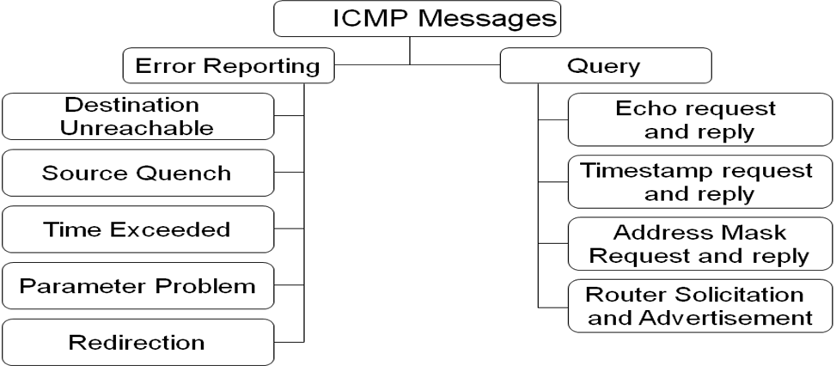

TRANSPORT LAYER PROTOCOLS
- Responsible for process to process delivery of the entire message.
- Ensure that whole message arrives intact .
- Also seeing error control and flow control at the source to destination level.
- Transport Layer Protocol use Port Address to route the packet to specific process.
- Protocols: TCP,UDP
PORT ADDRESS
- 16 bit integer number.
- Useful to identify process on particular host.
- Assigned by ICNA ( Internet Assigned Number Authority ).
- 3 type Of Port Address
    - Well Known
    - Registered
    - Dynamic
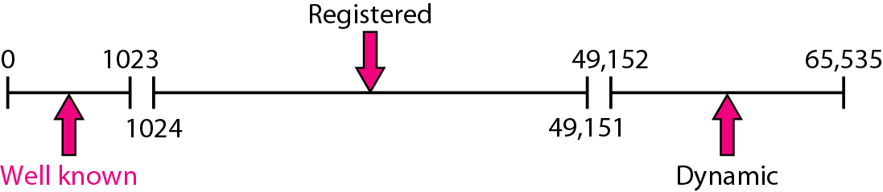

- Well known : Assigned by ICANN
- Registered :
          - Cant assigned or controlled by ICANN.
          - Only registered with ICANN to prevent Duplication
- Dynamic :
        - Used as private or temperory port numbers.
        - Neither controlled or registered with ICANN.
- IP address and Port Number play important role in selecting final destination.
- IP Address : Defines the host among the different host in world.
- Port Number : Defines one of the process on this particular host.
SOCKET ADDRESS
- Combination of IP address and Port Number.
- Define process uniquely.

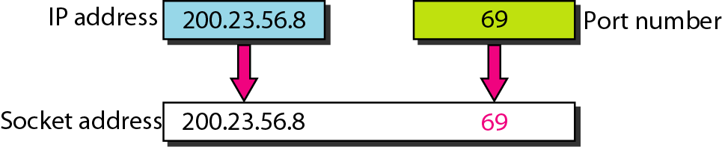

TCP (TRANSMISSION CONTROL PROTOCOL)
- TCP provides connection-oriented reliable transport service.
- To deliver data as stream of bytes.
- Segment: TCP takes large block of information from application and breaks them into segment.
- Acknowledgement:
- After segments are sent, TCP waits for an acknowledgement of the receiving end’s TCP virtual circuit session.
- Retransmitting those that aren’t acknowledged.
- The value of the acknowledgment field in a segment defines the number of the next byte a party expects to receive.
- Provide guarantee that all the data delivered to the other end.
- Sequence Number
  - TCP number and sequence each segment sent to destination.
  - So, Destination TCP protocol can put the segment back into the order.
  - Started Sequence number is any random number generated by sending machine.
  - Define the first byte contained in segment.
- Virtual Circuit
  - Before transmitting host start to send segment, TCP protocol contact the destination’s TCP to establish connection. What is created is known as “Virtual Circuit”.
  - This type of communication is called Connection oriented .
- Connection oriented
- Create a virtual circuit between sender and receiver.
- All segment passed through this path or virtual circuit.
- After segment receive by receiver, it sent acknowledgement to sender PC.
- Once transmission is over, virtual circuit is terminated.
- Flow Contol :
  - Because sending and receiving process may not write or read data at the same speed, TCP need buffers for storage.
  - Buffer has three chambers.
    - White : Empty chambers filled by producer.
    - Gray : Hold bytes that have been sent but not acknowledge. TCP contain this until it receive acknowledgement for receiver.
    - Colored : Byte to be sent by sending tcp.

  - 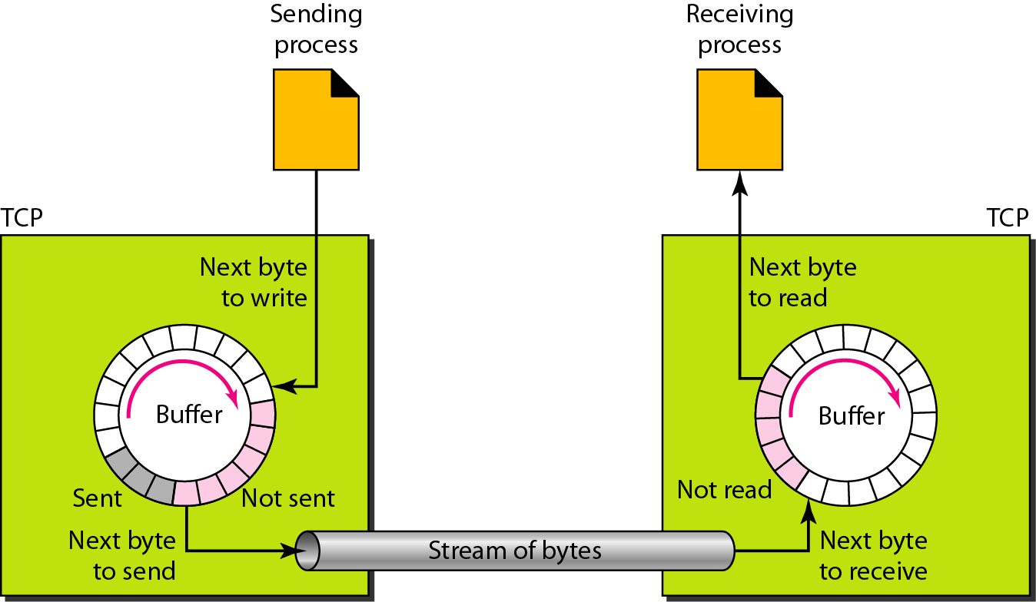

- TCP is
    - Full deplex
    - Connection-oriented
    - Reliable
    - Accurate protocol

- Disdvantage: Slow compare to UDP.
    - Establishing all terms and condition in addition to error checking makes TCP communication slow compare to other Transport layer protocol, UDP.
    - It is complicated and costly.
TCP SEGMENT
- A SEGMENT is variable length packet consists of two part:
1. Header
2. Data
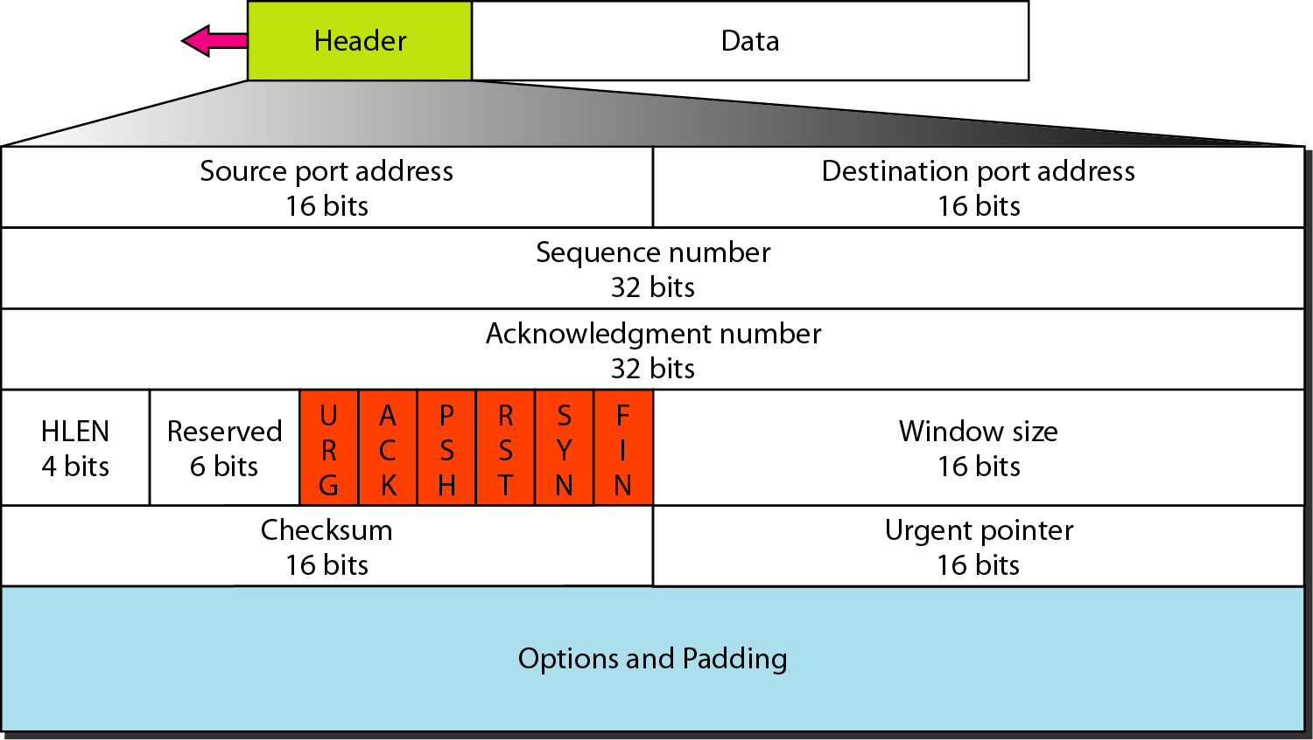
- Segment consists of a 20-60 byte header.
- Header is 20 bytes if there is no options.
- It is 60 bytes if it contains options.
- Source Port Address:
    - 16 bit field define the port number of the application program in the host that send the segment.
- Destination Port Address:
    - 16 bit field define the port number of the application program in the host that receive the segment.
- Sequence Number
    - 32 bit field defines the number assigned to the first byte of data contained in segment.
    - Tells the destination which bytes in this sequence comprises the first byte in the segment.
    - Each party uses a random number generator to create an initial sequence number.
    - Acknowledgement Number
    - 32 bit field defines the byte number that the receiver of the segment is expecting to receive from the other party.
    - If the receiver of the segment has successfully received byte number x , it defines X+1 as acknowledgement number.
- Header Length
    - 4 bit field indicates the number of 4 bytes words in TCP header.
    - Length of header can be between 20 and 60 bytes.
    - Reserved : For future use.
    - Control
    - Define 6 different control bits of flag.
    - One or more of bits can be set at a time.
    - This bit enable flow control, connection establishment and termination, connection abortion and the mode of data transfer.
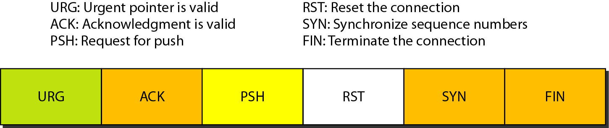
- Windows size
- Define the size of windows that other party must maintain.
- Length is 16 bit so max. size of window is 65,535 bytes.
- Checksum
    - 16 bit field inclusion of checksum in TCP is mandatory.
    - Urgent Pointer
    - 16 bit field valid only if urgent flag bit is set.
    - Used when urgent data is used.
    - Added number to the seq. number to obtain the number of the first urgent byte in data section of the segment.
    - Option :Upto 40 bytes of optional information in TCP header.
MULTIPLEXING – DEMULTIPLEXING AT TRANSPORT LAYER
    - Multiplexing:
    - The job of gathering data at the source host from different application processes, enveloping the data with header information to create segments, and passing the segments to the network layer is called multiplexing.
- Demultiplexing
    - At the receiving end, the transport layer can then examine this field to determine the receiving process, and then direct the segment to that process. This job of delivering the data in a transport-layer segment to the correct application process is called demultiplexing.

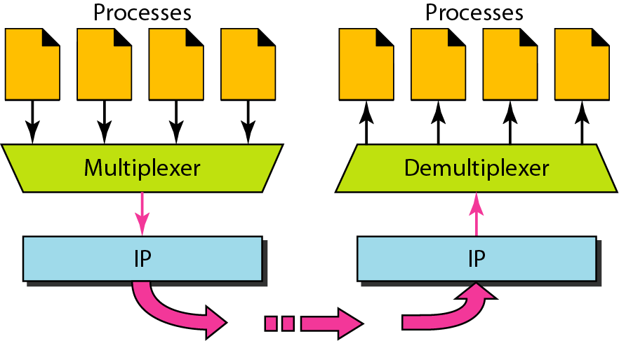

- Suppose you are sitting in front of your computer, and you are downloading Web pages while running one FTP session and two Telnet sessions.
- You therefore have four network application processes running -- two Telnet processes, one FTP process, and one HTTP process.
- When the transport layer in your computer receives data from the network layer below, it needs to direct the received data to one of these four processes. Let's now examine how this is done.
- The job of gathering data at the source host from different application processes, enveloping the data with header information be used in to create segments, and passing the segments to the network layer is called multiplexing.
- Each transport-layer segment has a field (PORT ADDRESS) that contains information that is used to determine the process to which the segment's data is to be delivered.
- At the receiving end, the transport layer can then examine this field to determine the receiving process, and then direct the segment to that process. This job of delivering the data in a transport-layer segment to the correct application process is called demultiplexing.
- UDP and TCP perform the demultiplexing and multiplexing jobs by including two special fields in the segment headers: the source port number field and the destination port number field.

UDP ( USER DATAGRAM PROTOCOL )
- Full Name:User Datagram Protocol
- UDP provides connectionless process-to-process communication.
- Can not set up dedicated end to end connection.
- UDP packets are called user Datagram.
- Communication is achieved by transmitting information in one direction from source to destination without verifying the readiness or state of the receiver.
- Doesn’t provide flow control.
- Unreliable – When a message is sent, it cannot be known if it will reach its destination; it could get lost along the way. There is no concept of acknowledgment, retransmission, or timeout.
- Not ordered – If two messages are sent to the same recipient, the order in which they arrive cannot be predicted.
- Lightweight – There is no ordering of messages, no tracking connections

DIFFERENCE: TCP Vs UDP( write as per number of marks )
TCP | UDP
Connection oriented | Connection less
Guarantee delivery | Doesn’t guarantee delivery
Send acknowledgement | Doesn’t Send acknowledgement
Segment and sequencing | Doesn’t provide sequencing
Provide flow control | Doesn’t provide flow control.
Resend dropped segment | Doesn’t resend dropped segment.
Slower than UDP. | Faster than TCP.
HTTP, HTTPS, TELNET,FTP,SMTP | DNS,DHCP,TFTP,RIP,VOIP

 | TCP | UDP
Acronym for: | Transmission Control Protocol | User Datagram Protocol
Function: | As a message makes its way across the internet from one computer to another. This is connection based. | UDP is also a protocol used in message transport or transfer. This is not connection based which means that one program can send a load of packets to another and that would be the end of the relationship.
Usage: | TCP is used in case of non-time critical applications. | UDP is used for games or applications that require fast transmission of data. UDP's stateless nature is also useful for servers that answer small queries from huge numbers of clients.
Examples: | HTTP, HTTPs, FTP, SMTP Telnet | DNS, DHCP, TFTP, SNMP, RIP, VOIP
Ordering of data packets: | TCP rearranges data packets in the order specified. | UDP cannot arrange data packet in order.
Speed of transfer: | The speed for TCP is slower than UDP. | UDP is faster because there is no error-checking for packets.
Reliability: | There is absolute guarantee that the data transferred remains intact and arrives in the same order in which it was sent. | There is no guarantee that the messages or packets sent would reach at all.
Header Size: | TCP header size is 20 bytes | UDP Header size is 8 bytes.
Data Flow Control: | TCP does Flow Control. | UDP does not have an option for flow control
Error Checking: | TCP does error checking | UDP does error checking, but no recovery options.
Acknowledgement: | Acknowledgement segments | No Acknowledgment
DIFFERENCE: TCP VS UDP

DIFFERENCE : TCP Vs UDP

DIFFERENCE : TCP Vs IP
FEATURES OF NETWORK OS

Windows
DirectoryServices
A directory service is a database of user accounts and other information that network administrators use to control access to shared network resources. When users connect to a network, they have to be authenticated before they can access network resources. Authentication is the process of checking the user's credentials (usually a user name and a password) against the directory. Users that supply the proper credentials are permitted access according to the permissions specified by the network administrator.
Client Support
Windows 3.x, Windows 95, Windows 98, and Windows NT Workstation 4.0 Windows 2000 Professional, Xp Pro. Vista Ultimate, Vista Business.
Interoperability
Windows 2000,2003,2008 Server supports UNIX, Novell NetWare, Windows NT Server 4.0, and Macintosh.
Authentication
Successful user authentication in a Windows 2000,2003,2008 computing environment consists of separate processes: interactive logon, which confirms the user's identification to either a domain account or a local computer, and network authentication, which confirms the user's identification to any network service that the user attempts to access.
Types of authentication
Kerberos V5 is used with either a password or a smart card for interactive logon. It is also the default method of network authentication for services.The Kerberos V5 protocol verifies both the identity of the user and network services Secure Socket Layer/Transport Layer Security (SSL/TLS) authentication, is used when a user attempts to access a secure Web server.
File and Print Services
You can add and maintain printers in Windows server using the print administration wizard, and you can add file shares using Active Directory management tools. Windows server also offers Distributed File Services, which let you combine files on more than one server into a single share.
Active Directory
After many years of anticipation, Microsoft introduced an enterprise directory service in the Windows 2000 Server product line, called Active Directory. It uses a hierarchical tree design comprised of container and leaf objects. The fundamental unit of organization in Active Directory directory service is the domain, but; you can group domains together into a tree, and even group multiple trees together into a forest. Domains that are in the same tree automatically have bidirectional trust relationships established between them, which eliminates the need for administrators to create them manually. The trust relationships are also transitive , meaning that if Domain A trusts Domain B and Domain B trusts Domain C, then Domain A trusts Domain C.
Security
User-level security protects shared network resources by requiring that a security provider authenticate a user’s request to access resources. The domain controller , grants access to the shared resource by verifying that the user name and password are the same as those on the user account list stored on the network security provider. Because the security provider maintains a network-wide list of user accounts and passwords, each client computer does not have to store a list of accounts. Share-level security protects shared network resources on the computer with individually assigned passwords. For example, you can assign a password to a folder or a locally attached printer. If other users want to access it, they need to type in the appropriate password. If you do not assign a password to a shared resource, every user with access to the network can access that resource.

FTP
- File Transfer Protocol (FTP) is a standard network protocol.
- The implementation of FTP dates from 1971 when a file transfer system between MIT machines (Massachusetts Institute of Technology) was developed.
- Used to transfer files from one host to another host over a TCP-based network, such as the Internet.
Role of FTP
- The aim of FTP protocol is to:
- Allow file sharing between remote machines.
- Allow independence between client and server machine system files .
- Enable efficient data transfer .
- FTP is built on a client-server architecture .
- Uses separate control and data connections between the client and the server.
- To transfer files with FTP, you use a program often called the client.
- An FTP client program initiates a connection to a remote computer running FTP server software.
- After the connection is established, the client can choose to send and/or receive copies of files, singly or in groups.
- To connect to an FTP server, a client requires a username and password as set by the administrator of the server. Many public FTP archives follow a special convention for that accepts a username of "anonymous."
Weakness of FTP
- FTP was not designed to be a secure protocol and has many security weaknesses . Following listed a vulnerability to the following problems:
- Brute force attacks
- Bounce attacks
- Packet capture (sniffing)
- Port stealing
- Spoof attacks
- Username protection
- FTP is not able to encrypt its traffic; all transmissions are in clear text, and usernames, passwords, commands and data can be easily read by anyone able to perform packet capture on the network.
HTTP
- Full Name : Hyper Text Transfer Protocol.
- It is an application layer protocol for distributed, collaborative, hypermedia information systems.
- HTTP is the foundation of data communication for the World Wide Web.
- Hypertext is structured text that uses logical links (hyperlinks) between nodes containing text.
- HTTP is the protocol to exchange or transfer hypertext.
- The aim of HTTP protocol is to allow transfer of files (essentially in HTML format) between a browser (the client) and a Web server located using a character string called a URL.
- HTTP functions as a request-response protocol in the client-server computing model.
- A web browser may be the client and an application running on a computer hosting a web site may be the server
- Communication between the browser and server takes place in two stages:
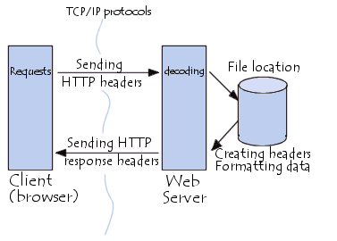
- The client makes a HTTP request
- The server processes the request then sends a HTTP response.
- The response contains completion status information about the request and may also contain requested content in its message body.
- HTTP is an application layer protocol designed within the framework of the Internet Protocol Suite.
- Its definition presumes an underlying and reliable transport layer protocol and Transmission Control Protocol (TCP) is commonly used.
RIP
- Full Name : Routing Information Protocol.
- RIP is a dynamic, distance vector routing protocol.
- RIP uses UDP port 520 for route updates.
- RIP calculates the best route based on hop count.
- Each RIP router transmitted full updates every 30 seconds
- While RIP requires less CPU power and RAM than some other routing protocols .
- RIP prevents routing loops by implementing a limit on the number of hops allowed in a path from the source to a destination.
- The maximum number of hops allowed for RIP is 15.
- This hop limit, however, also limits the size of networks that RIP can support.
- A hop count of 16 is considered an infinite distance, in other words the route is considered unreachable.
- There are three versions of the Routing Information Protocol: RIPv1, RIPv2, and RIPng.
X.25
- X.25 is a standard suite of protocols used for packet switching across computer networks.
- The X.25 protocols works at the physical, data link, and network layers of the OSI model.
- Each X.25 packets contains up to 128 bytes of data.
- The X.25 network handles packet assembly at the source device, delivery, and then dis-assembly at the destination.
- X.25 packet delivery technology includes not only switching and network-layer routing, but also error checking and re-transmission .
- X.25 was originally designed more than 25 years ago to carry voice over analog telephone lines (dialup networks).
- Typical applications of X.25 include automatic teller machine networks and credit card verification networks. X.25 also supports a variety of mainframe terminal/server applications.

FILE SERVER
- A file server is a computer attached to a network .
- That has the primary purpose of providing a location for shared disk access, i.e. shared storage of computer files such as documents, sound files, photographs, movies, images, databases, etc. that can be accessed by the workstations that are attached to the same computer network.
- The term server highlights the role of the machine in the client–server scheme, Where the clients are the workstations using the storage.
- A file server is not intended to perform computational tasks, and does not run programs on behalf of its clients.
- It is designed primarily to enable the storage and retrieval of data while the computation is carried out by the workstations.
- File servers are commonly found in schools and offices, where users use a LAN to connect their client computers.
Types Of File Server
- A file server may be
- Dedicated
- Non-dedicated.
Dedicated File Server
- A dedicated server is designed specifically for use as a file server, with workstations attached for reading and writing files and databases.
- A dedicated file server means that there may be a specific computer server that fulfills this function, typically for a larger network, and has specialized hardware and software to handle the greater workload.
- This may include more hard drive memory storage, better cooling systems, better security such as limited physical access, and specialized software contained within special server operating systems.
Non-Dedicated File Server
- A non-dedicated file server just means that the computer functioning as a file server isn't used exclusively as such, and may also be used for other purposes, such as a workstation. This is more typical of small-scale systems, such as at home or in a small business.
- File servers may also be categorized by the method of access:
- Internet file servers are frequently accessed by File Transfer Protocol (FTP) or by HTTP
- Servers on a LAN are usually accessed by SMB/CIFS protocol (Windows and Unix-like) or NFS protocol (Unix-like systems).
APPLICATION SERVER
- An application server supplies shared capabilities to software applications on client server networks.
- Application server provide services to the network clients or support enterprice based applications.
- It is a server computer in a computer network dedicated to running certain software application.
- Some application servers keeps data and the application on the same computer, but it varies by application.
- Application server are specific to the applications they support, such as database server or business related applications.
- For example, websites use at least one application server may be used in a supporting role, such as database server storing content used by the web server and hosted websites.

http://books.google.co.in/books?id=cJZ-y1meZ8YC&pg=PA123&dq=application+server+in+computer+network&hl=en&sa=X&ei=STgoUuWyOo7RrQes9ICICA&ved=0CF0Q6AEwBg#v=onepage&q=application%20server%20in%20computer%20network&f=false

TCP | IP
Transmisssion control Protocol | Internet Protocol
Used at Transport Layer | Used at Network Layer.
Connection oriented protocol. | Connection less protocol.
Send process to process message delivery. | Node to node delivery of packet.
Use Port Address in header. | Use IP address in header.
More reliable | Less Reliable
Provide reordering . | Don’t provide.
concerned with guaranteed delivery of packets from source to destination.

